CAMP JABEZ

JR. WRANGLER MINISTRY

To God be the Glory, Great things He has Done!

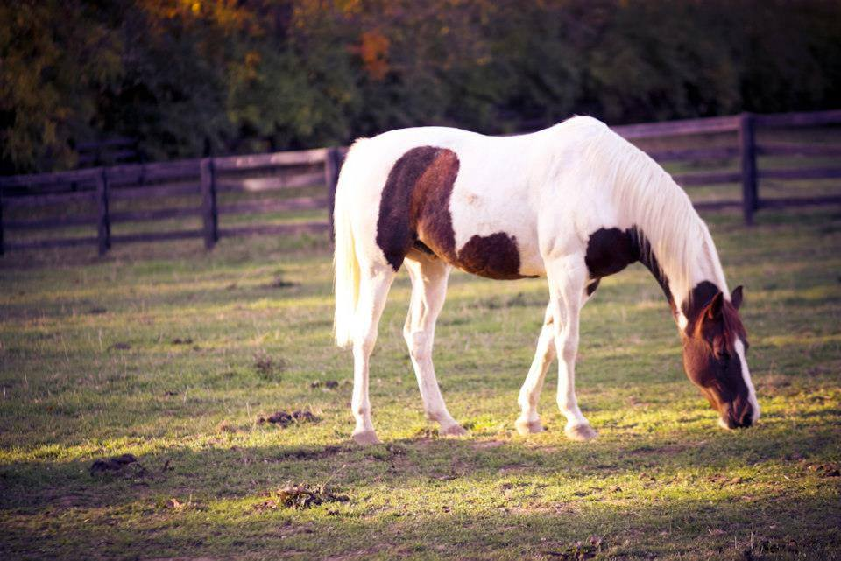

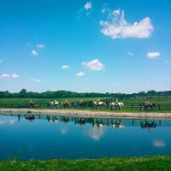

SO YOU WANT TO BE A WRANGLER…

Some people are wranglers and don’t know it. Daniel Webster has several definitions for a wrangler and one is: a person, who disputes, argues or quarrels and noisily. We hope that this is not you or your definition of a wrangler. His other definition is: a cowboy who rounds up livestock. We hope this comes
a little closer to your desires to be a wrangler.

WHAT IS A JR. WRANGLER
ABOUT?
Camp Jabez is a missionary operation. That may sound unusual but nevertheless true. It is the goal of Camp Jabez to be an extension of the mission field of the inner city. A Jr. Wrangler is someone who has a desire to serve the Lord through their love for His creation. As God has blessed us with a wonderful place, we need people who can appreciate God’s wonderful creation and strive to use it to His honor and glory.

JR. WRANGLER DUTIES
Your duties will all be related to horses. If you are wondering, the word equine comes from Latin and means horse. Some people just like to use fancy words. It all starts in the barn.
Remember and keep saying this phrase:
Barns are Beautiful.
They are beautiful because people love horses enough to keep their houses in good, clean condition. Horses are big and strong but sometimes it doesn’t take much to upset them or cause some health problems. Here are a few duty examples: cleaning water and grain buckets, keeping the walls of the stalls clean and of course the stalls need to be mucked. We will let you look that one up. The duties and responsibilities increase with training.

What doth the Lord require of thee, but to do justly, and to love mercy, and to walk humbly with thy God. Micah 6:8.

HOW IT BEGINS
The learning process starts with getting to know your surroundings. You will learn all the things about the barn that will assist
you in becoming a Jr. Wrangler. You will also learn the basics on how to take care of a horse. Yes, horses like grooming. It is a special time to get to know your horse and build a relationship with him. You will learn about the special grooming tools for this job. Horses do require equipment called tack. The word is abbreviated from tackle. You will learn how to halter and
lead a horse.

ADVANCING THROUGH THE RANKS
The Director of Equine Ministries has established guidelines for a progressive growth in knowledge and experience with the horses at the camp.
Knowledge of each individual horse is important. Just like people, they all have their own temperaments and bad days. The advanced Jr. Wrangler will learn how to detect these various moods of the horses and how to handle them appropriately. This is a very important part of safety in working with horses.

The advanced Jr. Wrangler will also learn how to work with each horse and his ground manners. Sometimes they can seem to forget what they are supposed to do; it requires constant training.

GETTING CLOSE TO THE TOP
As you advance in your training you will be able to assist in giving lessons to campers. This is one of the greatest joys of all! It is wonderful to take a fearful child and give him the confidence and ability to control a
1200-pound animal. It can open up a whole new world for youth who have not been too successful in life so far. We hope to make a difference.

YOU HAVE DONE IT!
We look forward to the day when many youth will have come this far along in the program and we truly have a whole bunch of Jr. Wranglers at Camp Jabez.

But as for me and my house, we will serve the
Lord. Joshua 24:15.

WHAT ELSE SHOULD I
KNOW?
Success in this program will entitle you to be involved in our missionary endeavors during our summer camps and mini camps. It will give you the opportunity to spend time on the mission field right here at
home. This involvement is very important to your growth and development as a Christian and is important on applications to college. Your hours spent in training and work will be documented.

WHAT IS THE NEXT STEP?
The age range for the Jr. Wrangler is 14 through 18 years of age. We also have a weight limit to ride the horses of 200 pounds.

Liability documents must be signed by parents or legal guardian.

A medical questionnaire must be completed.

Email the Director of Equine Ministries at Camp Jabez to express your interest in this program and appropriate arrangements will be made.

Director@GMission.org

In case of emergency call 911. Location is 3191 St. Rt. 380,
five miles south of Xenia, four miles east of Spring Valley. One half mile south of Spring- Valley Painters Creek Road.

After contacting emergency services, please call main camp office at: 937-223-4513 if camp staff is not present. Phone is answered 24 hours a day.

Please see that one person in your party has a cell phone. Camp phones are not readily accessible.

Camp Jabez
Outreach of the Gospel Mission. Inc.

Phone (937) 223-4513
Fax (937) 223-4246
WWW.GMISSION.ORG WWW.CAMPJABEZ.ORG

REV. 2/2018

